# Application Services

## Amazon Kinesis

* Streaming data is something which is generated by thousands of data sources – stock prices, game information, social network data, geo-spatial data, purchases from online stores, IoT sensor data.
* Kinesis is an AWS platform to load and analyze streaming data and the ability to build your own custom applications
* **Kinesis Streams**

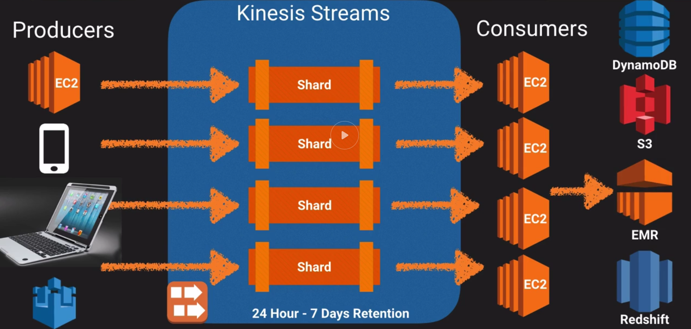

* + Allows real-time processing of streaming big data and the ability to read and replay records to multiple Amazon Kinesis Applications
  + Stores data for 24 hours to 7 days.
  + Data stored in **shards**
    - **5 TPS for Read**
    - **Data reads at 2MB per second**
    - **Write: 1000 records per second at 1MB /s**
  + Data consumers (EC2 instances) analyze the stream and then derive results/take next actions
  + Data capacity of stream is a function of the number of shards you specify for the stream.
* **Kinesis Firehose**

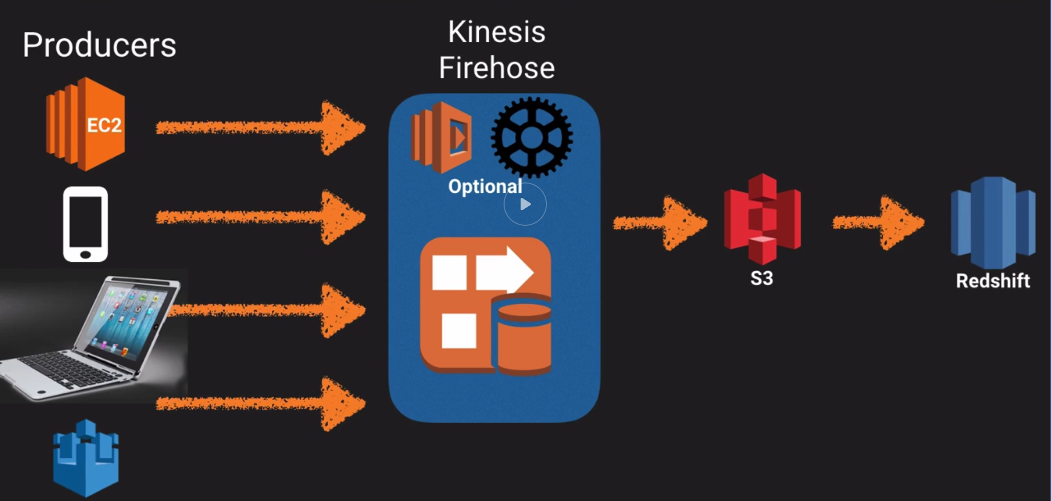

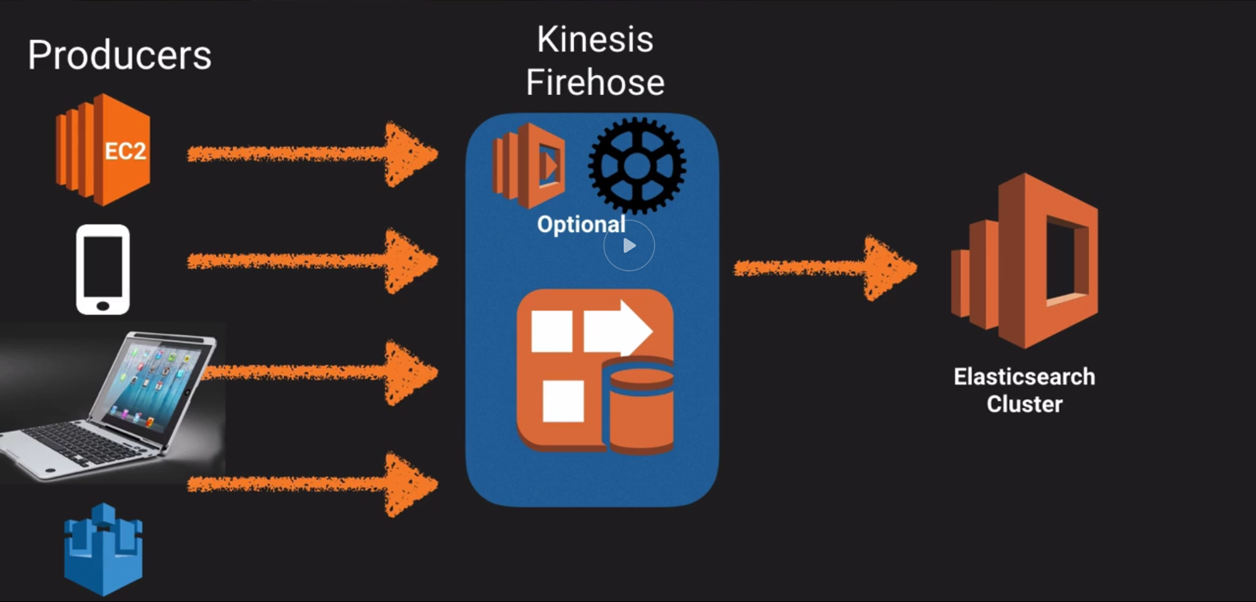

* + Don’t have to worry about shards, streams – completely automated.
  + No automatic data retention window. Data is either immediately analyzed or sent to S3 and then to Redshift, elastic search cluster
  + Data is immediately analyzed via **Lambda**.
* **Kinesis Analytics**

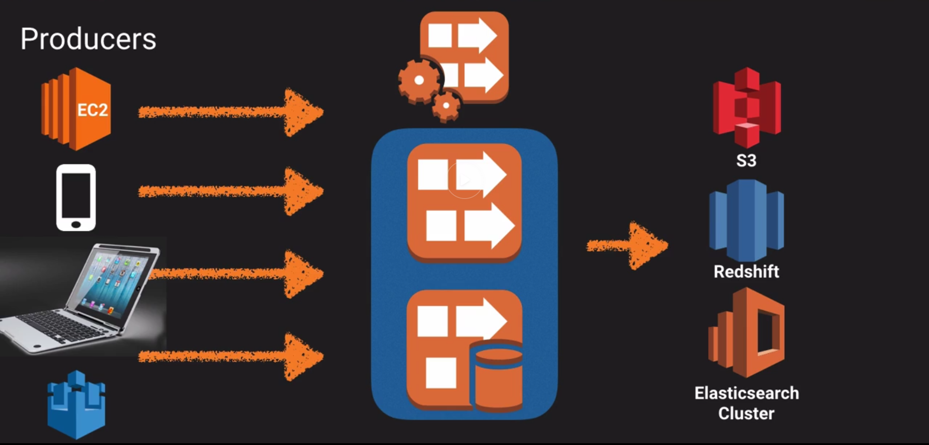

* + Run SQL type queries on top of data contained in Streams or Firehose and store the results in S3 / Redshift and Elastic Search cluster.
* *Exam Tip: Kinesis - process large streams of data. To process data - Amazon Redshift and Elastic Map Reduce*